

方法1:MP3到WAV轉換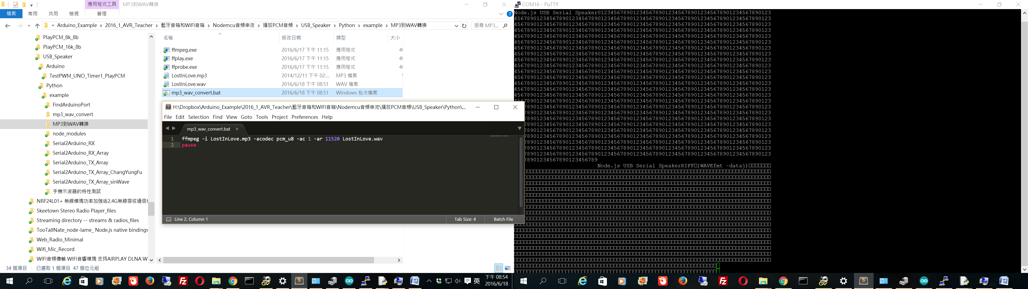

方法2:MP3到WAV轉換

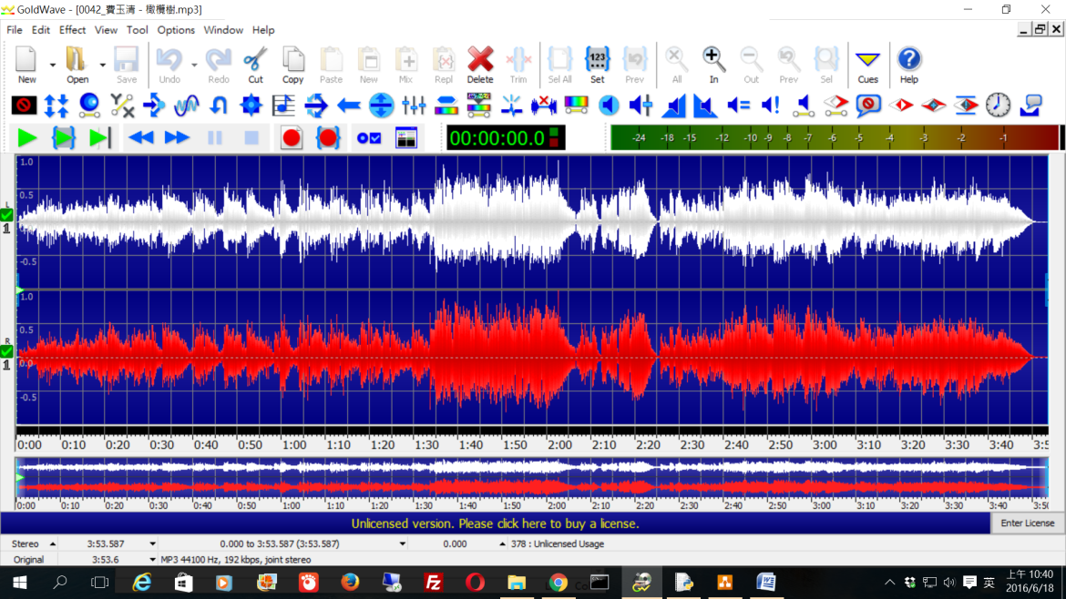

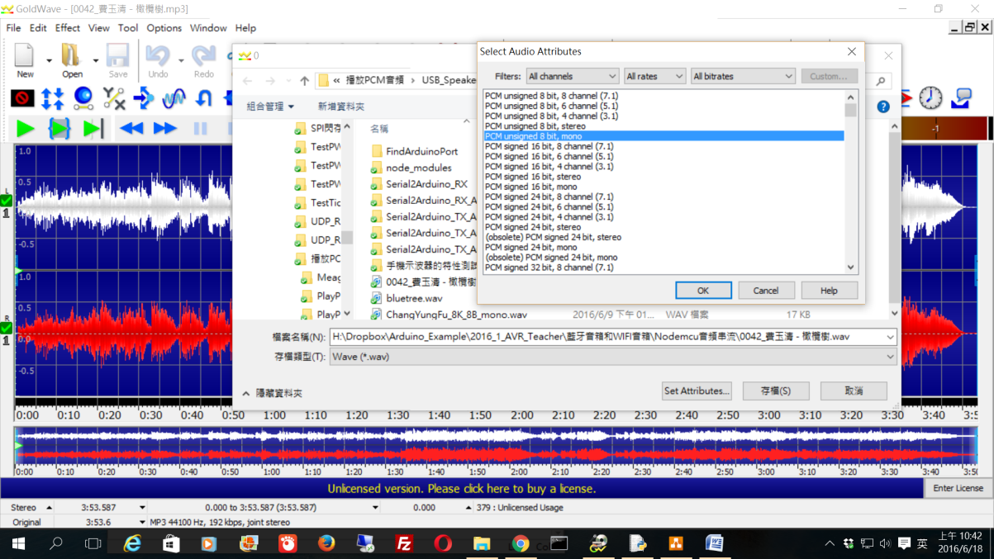

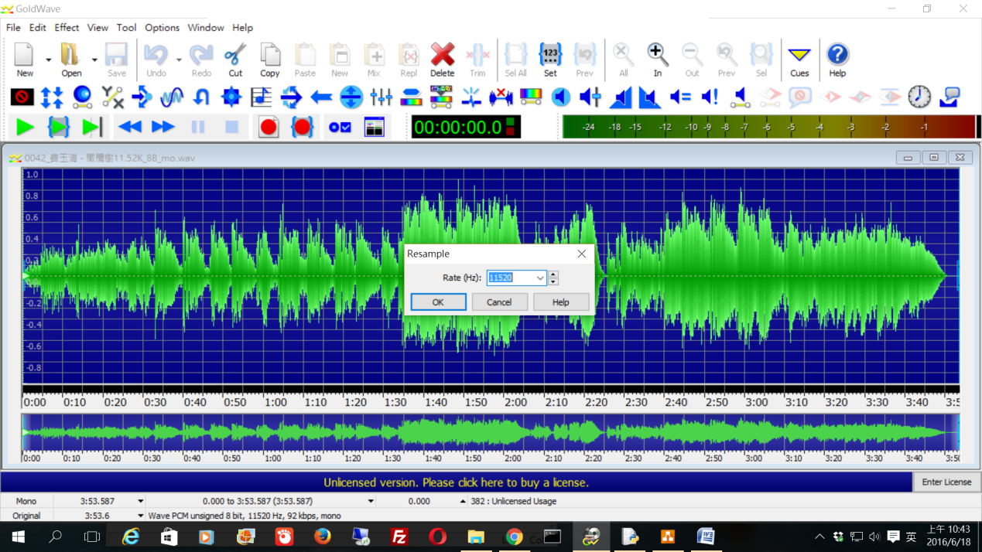

Arduino reciver:

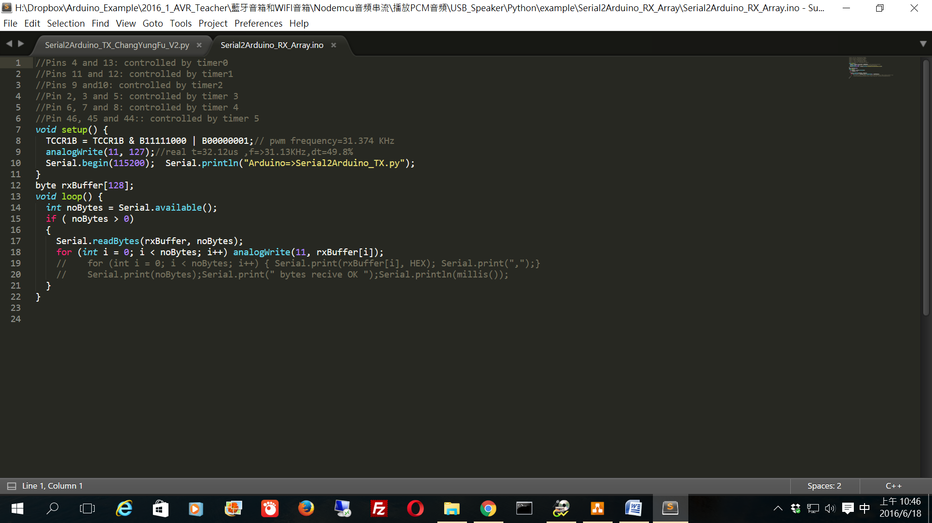

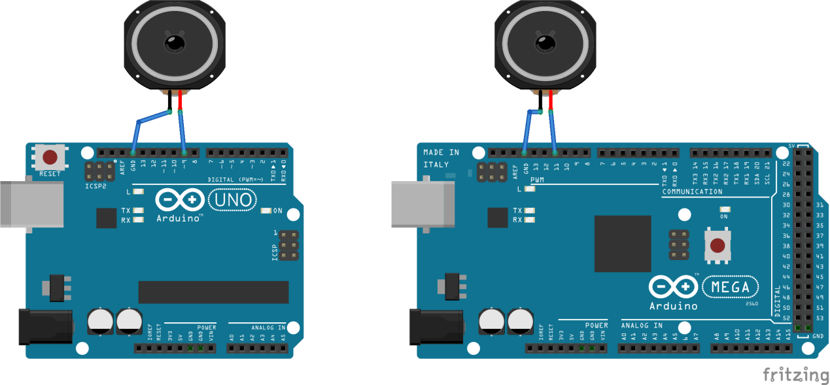

Node.js的發送器的代碼：

<https://www.dropbox.com/s/mhyok6g1nqcr17c/Serial2Arduino_TX_Array_V2.js?dl=0>

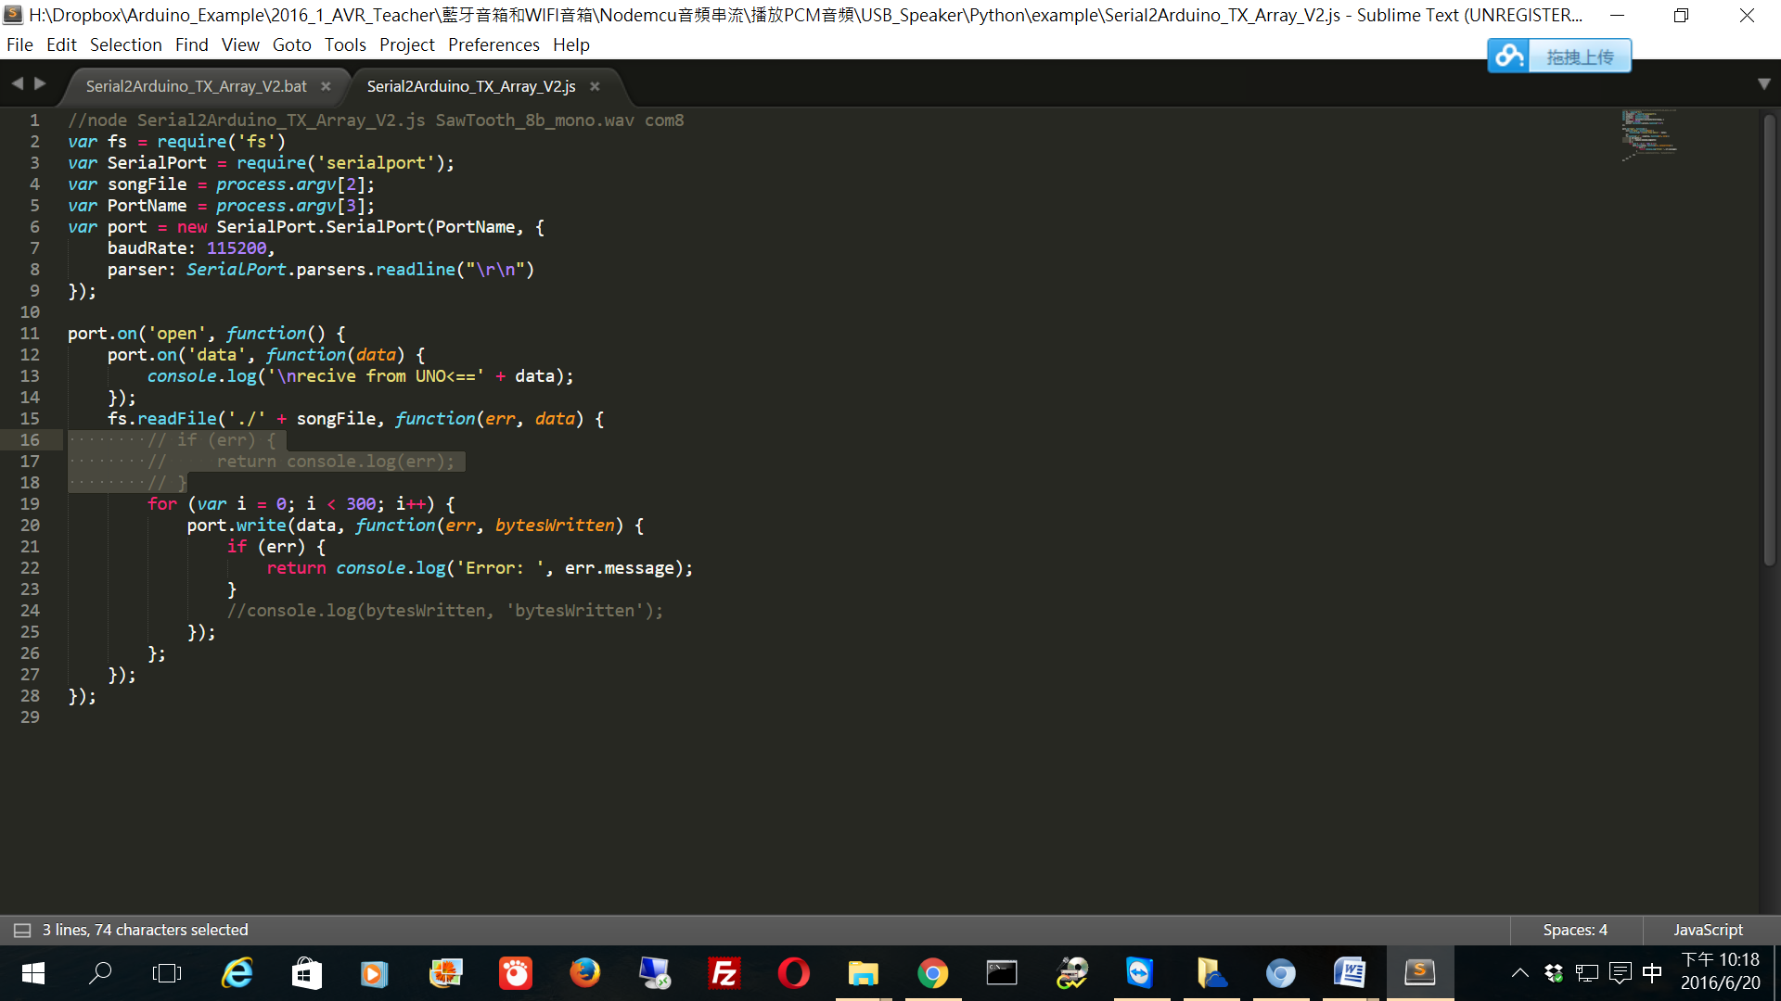

創建鋸齒波

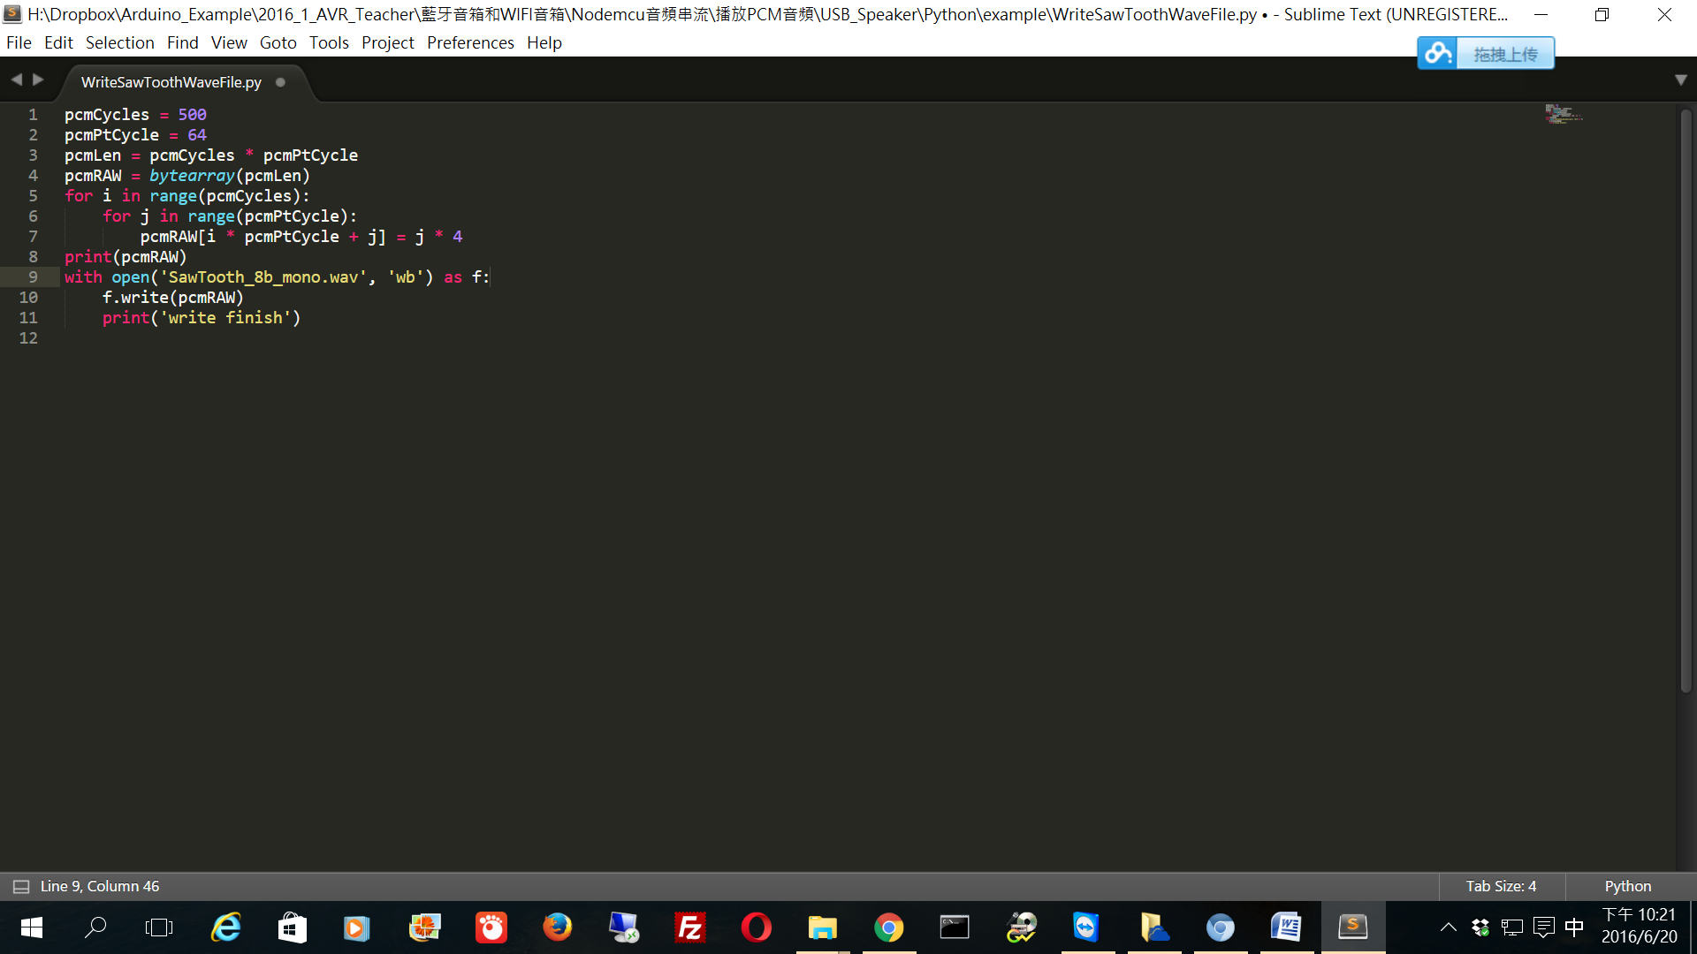

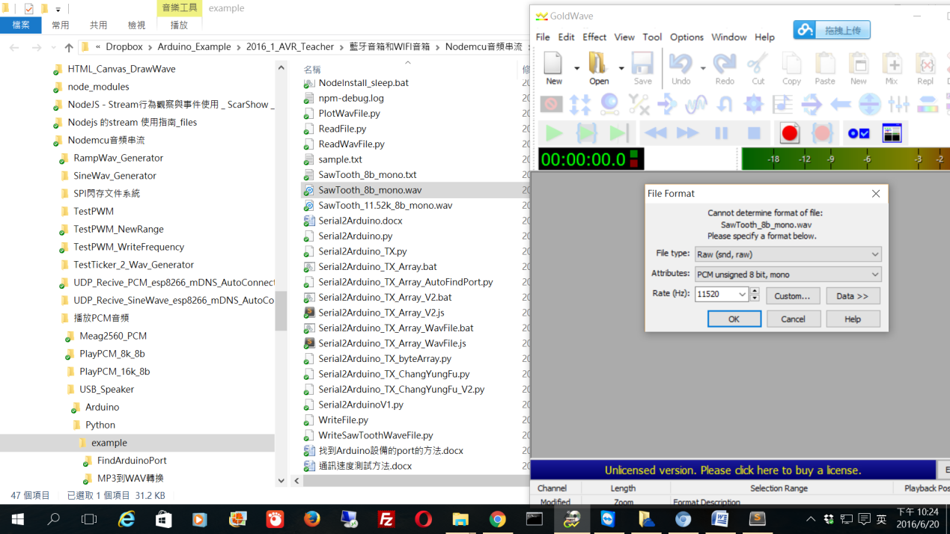 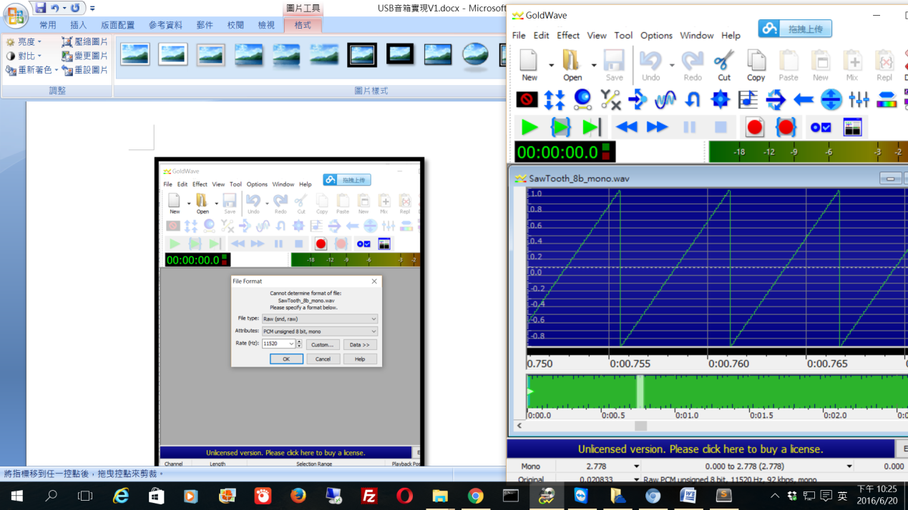

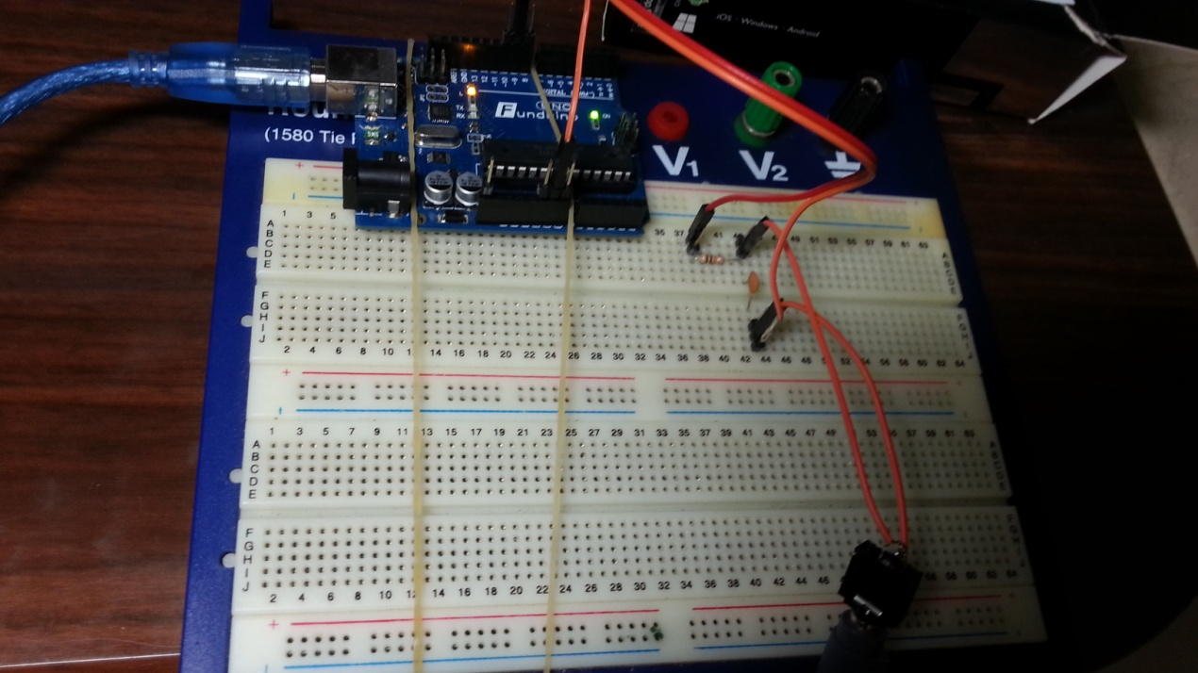

連接PC音頻線路輸入,作為示波器

RC低通濾波器，解調類比波

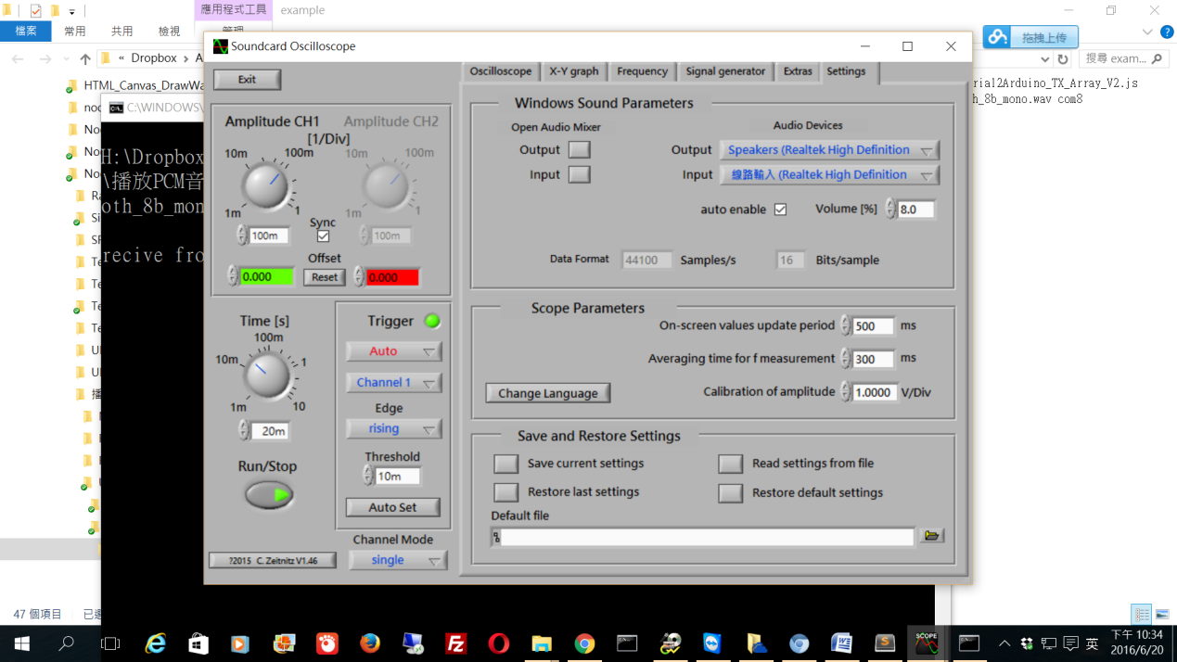

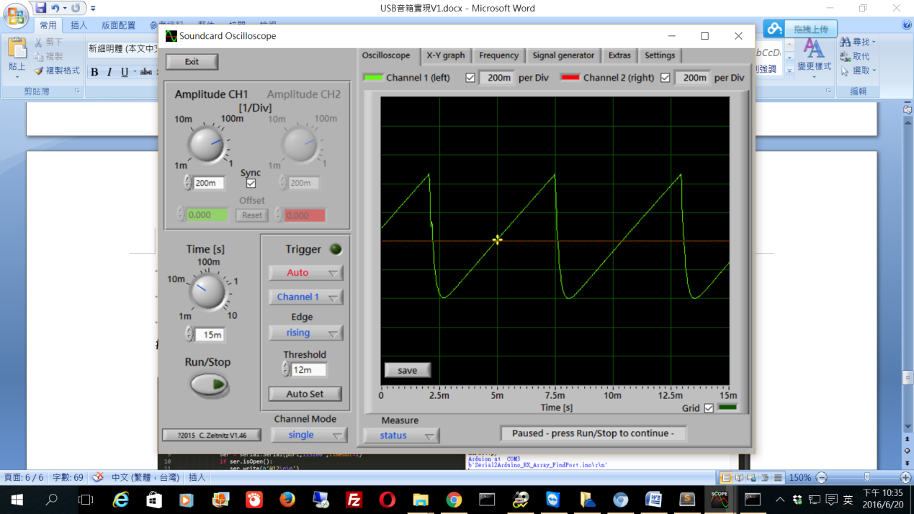

python的發送器的代碼：

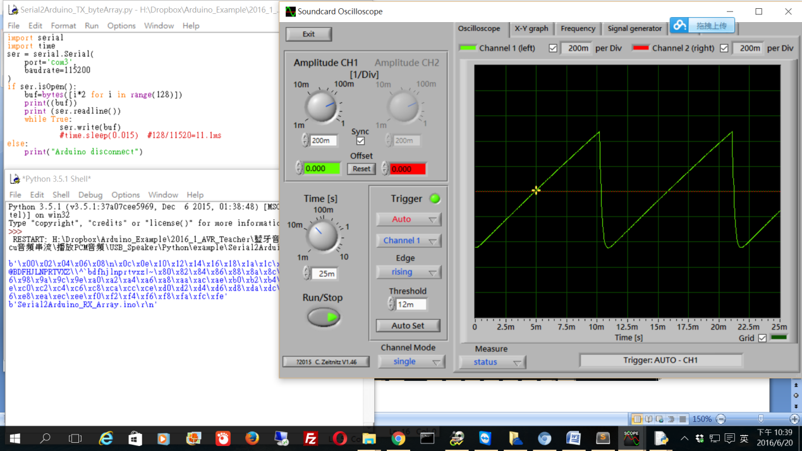

#自動找出Arduino的串口

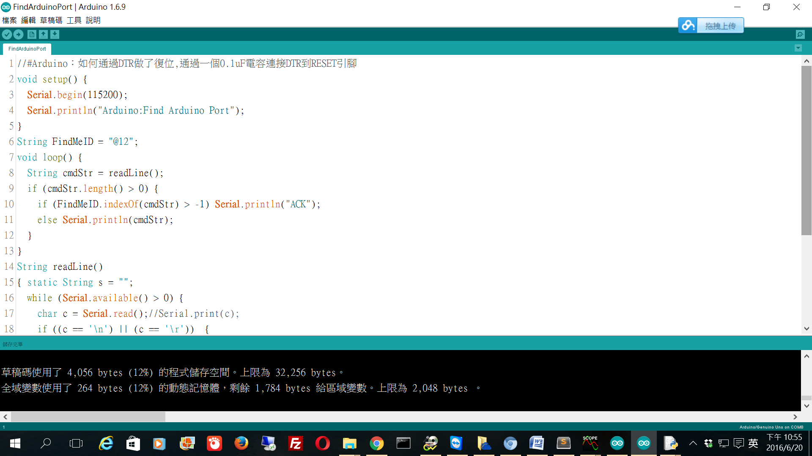

<https://www.dropbox.com/s/baipkc1ea07hal0/FindArduinoPort.ino?dl=0>

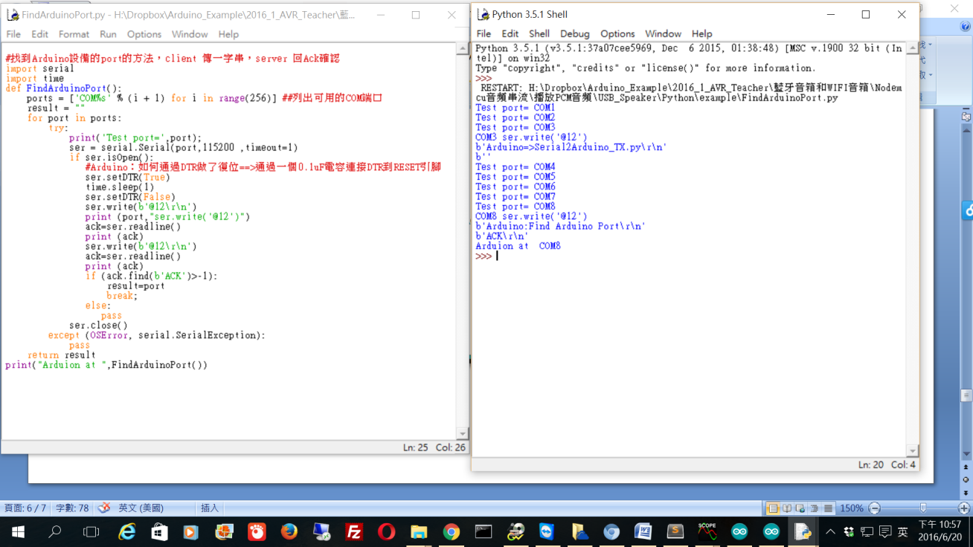

<https://www.dropbox.com/s/995gvhmlvj3g3td/FindArduinoPort.py?dl=0>

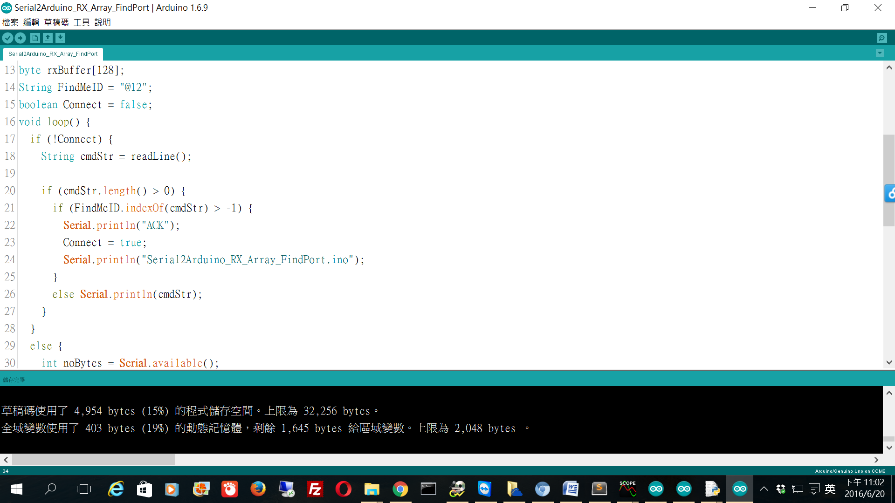

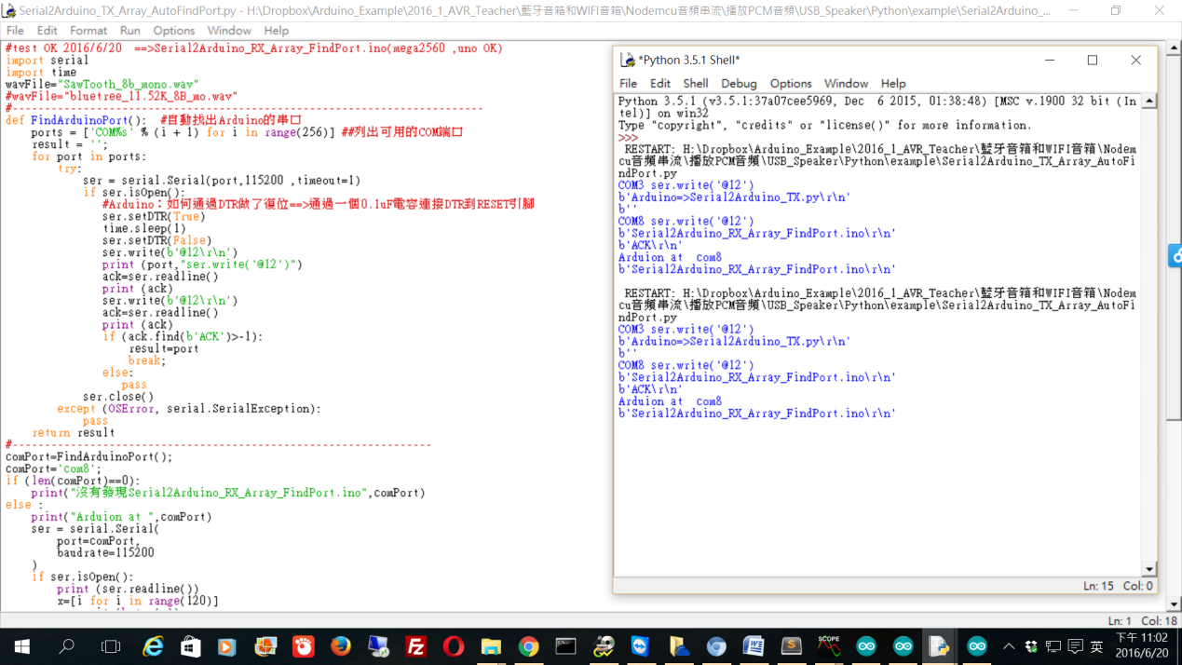

<https://www.dropbox.com/s/o20umyq6ygn483a/Serial2Arduino_TX_Array_AutoFindPort.py?dl=0>

<https://www.dropbox.com/s/5vn9uqze678s694/Serial2Arduino_RX_Array_FindPort.ino?dl=0>

<https://www.dropbox.com/s/7w8xq9396tk9fla/SawTooth_11.52k_8b_mono.wav?dl=0>

<https://www.dropbox.com/s/w7ykld7alkd5k91/ChangYungFu_8K_8B_mono.wav?dl=0>

<https://www.dropbox.com/s/0ctjjxkq59gukjp/bluetree_11.52K_8B_mo.wav?dl=0>

//--------------------------------------------------------------------------------------------------

NodeMCU reciver:

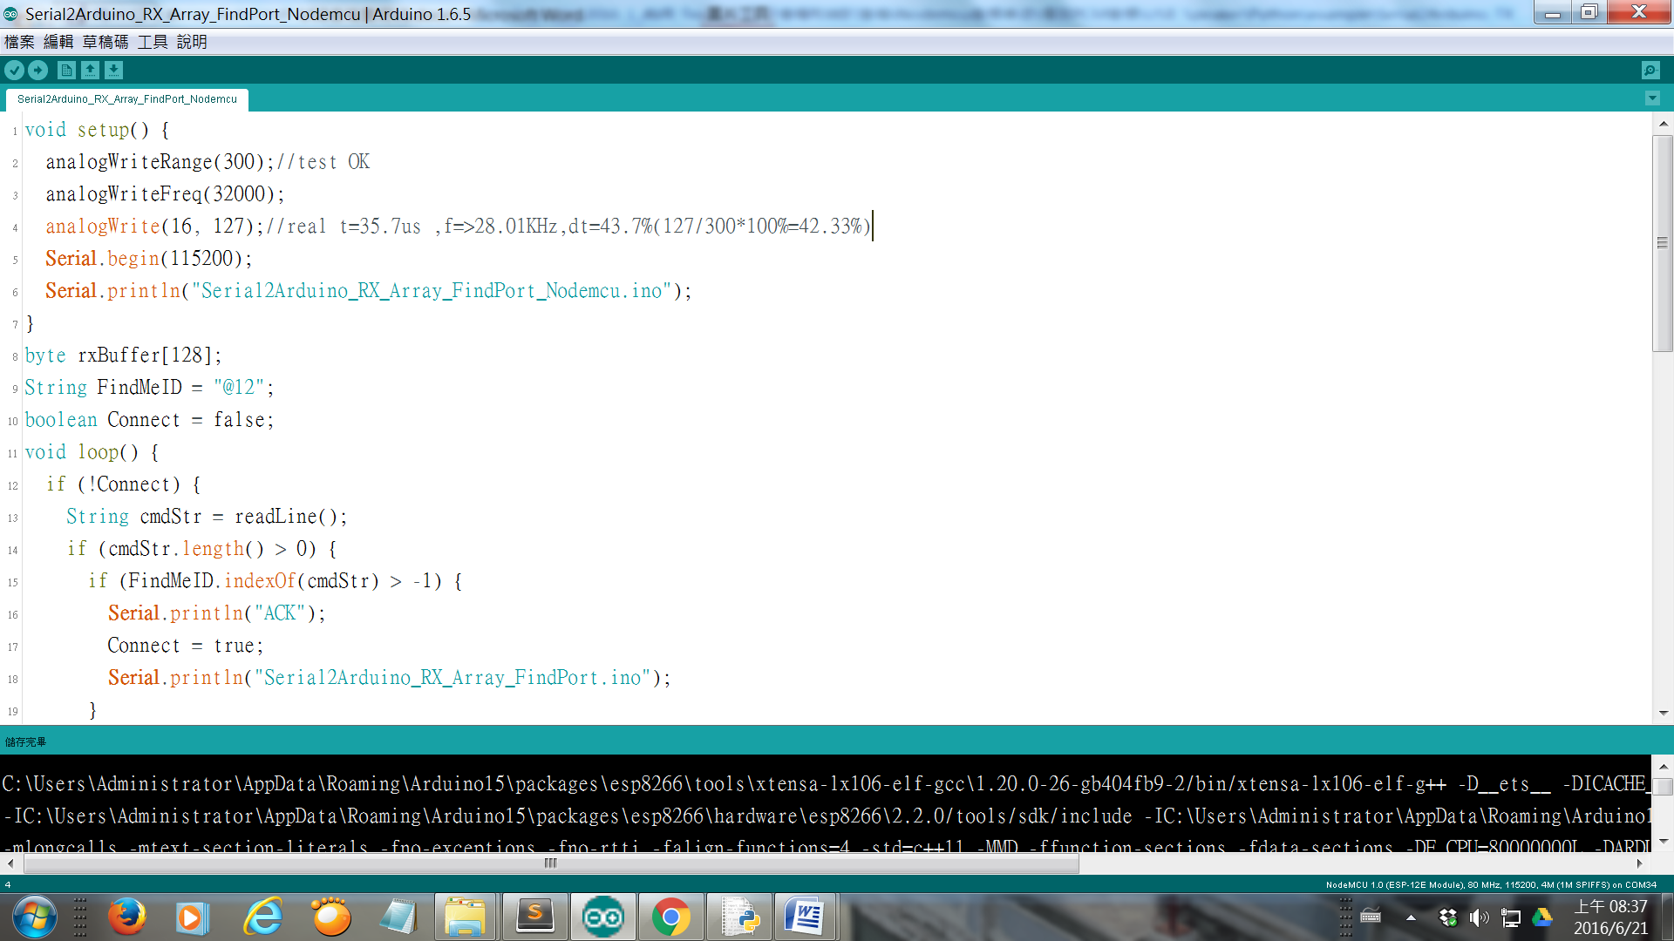

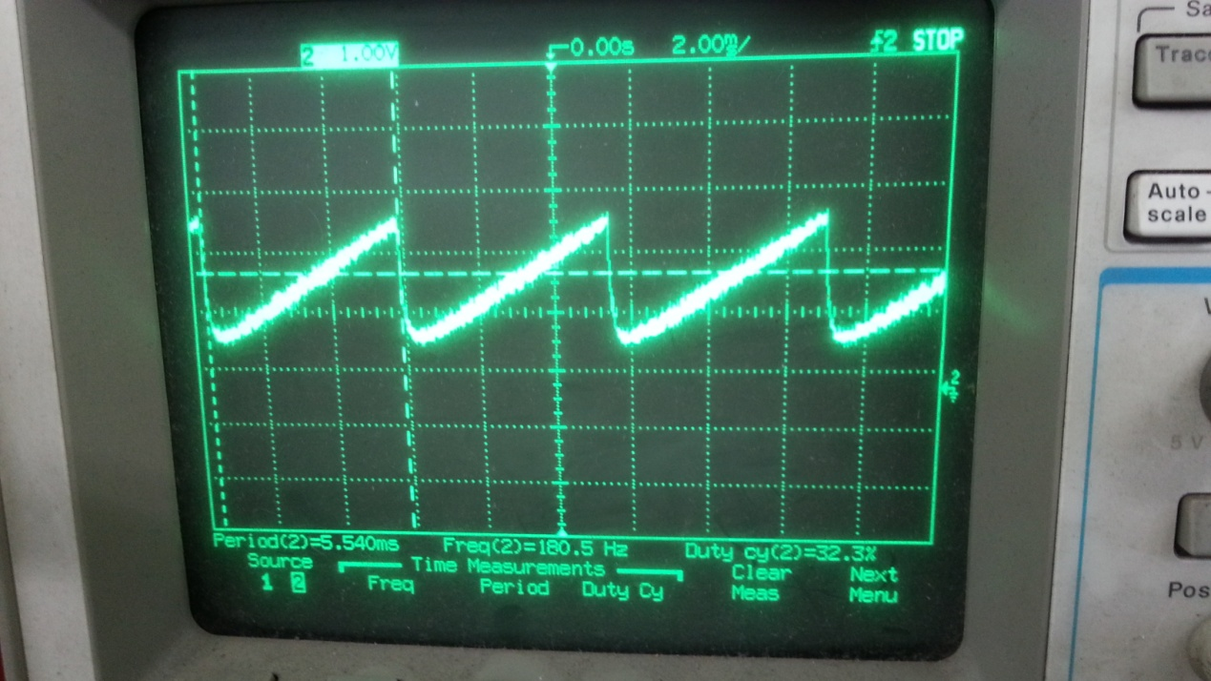

nodemcu PWM是軟件模擬，頻率和佔空比不穩定，在播放音樂,導致有一些火花噪音.

#自動找出Nodemcu的串口

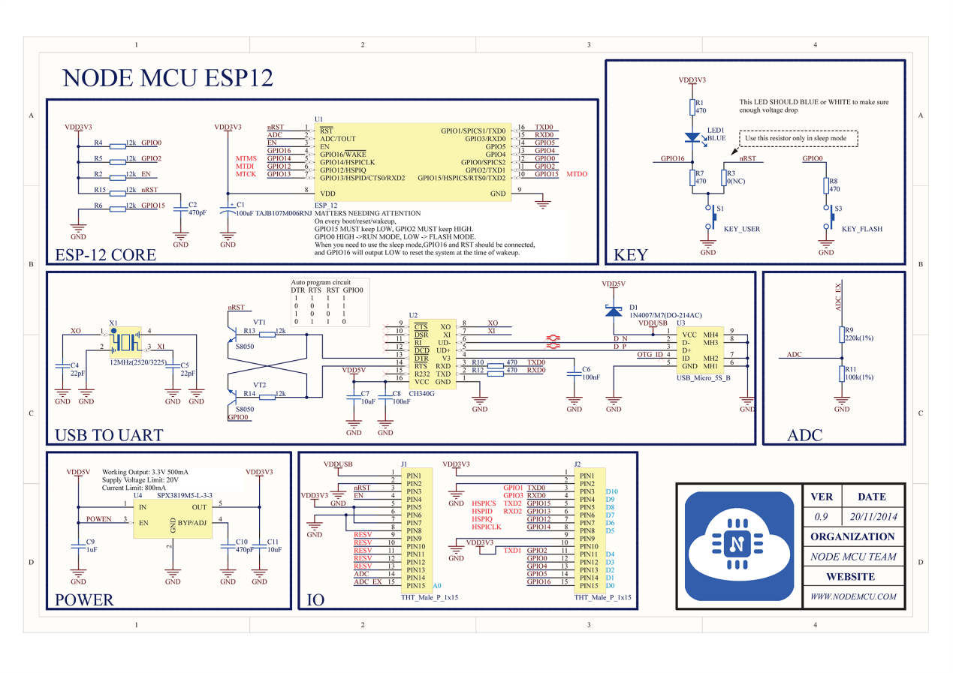

Reset true table

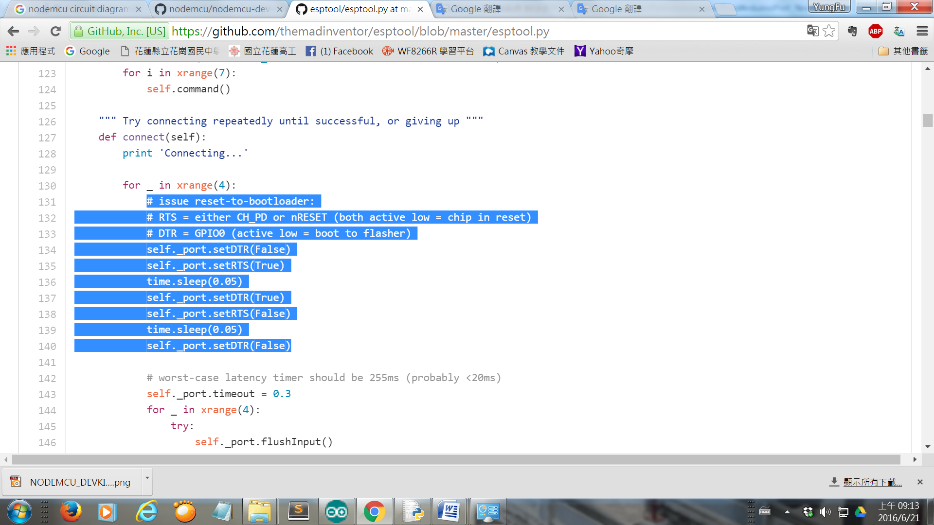

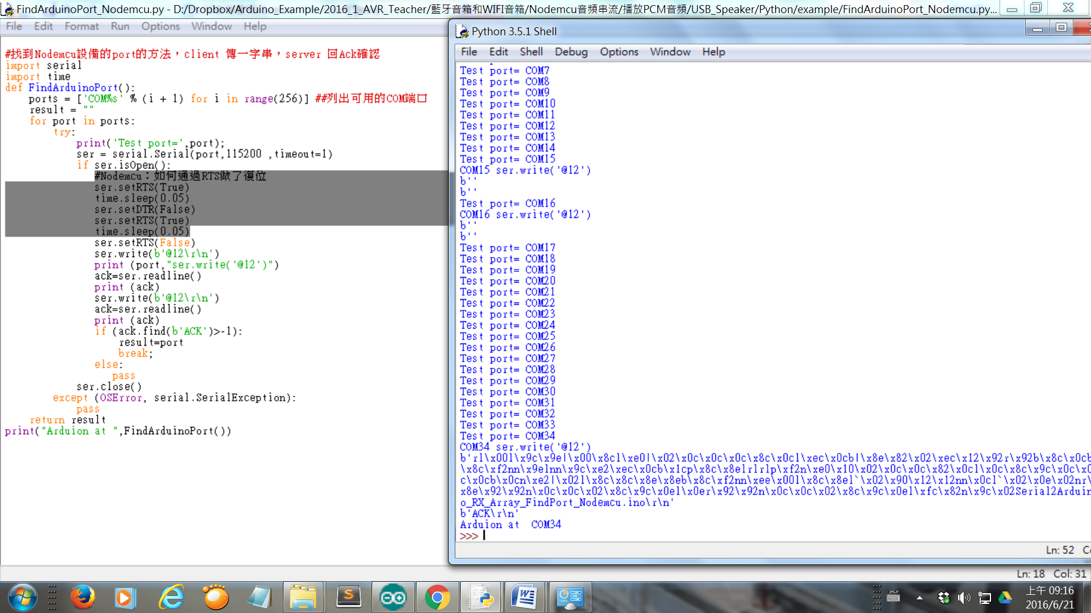

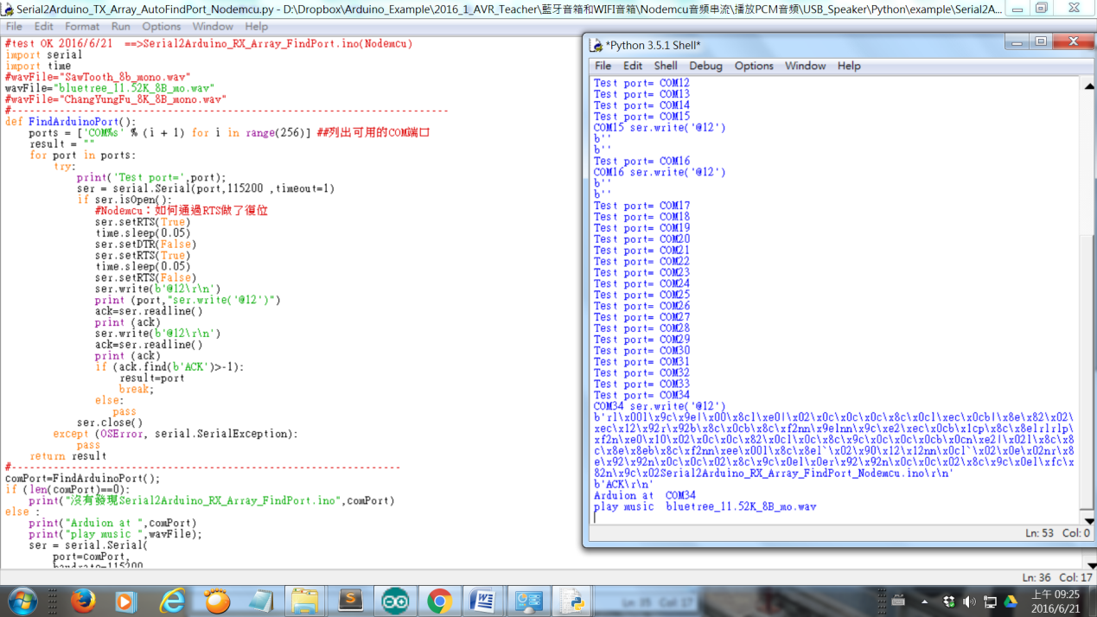

<https://www.dropbox.com/s/9p0cpkhlb8dnov8/Serial2Arduino_TX_Array_AutoFindPort_Nodemcu.py?dl=0>